Admin/Volunteer /Fields – selecting the County option shows US states only
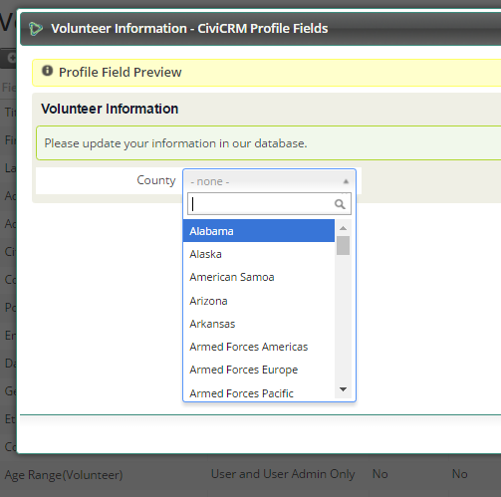
As does the Voluinteer Information Form used by volunteers to update their info from the Request Info email link:
